Recruitment Specialist- Job Description

- Create and publish job ads in various portals
- Network with potential hires through professional groups on various hiring Platforms
- Screen Resumes and job applications
- Conduct initial phone screens to create shortlists of qualified candidates and co-ordinate for the next levels of the interview
- Interview candidate’s in-person for a wide range of roles (Relationship Managers, Service Associates, Trainers etc.)
- Track hiring metrics including Interviewed, Feedback, Salary , Joining Dates/Maintain End to end Employee records
- Follow up with candidates throughout the hiring process and release offer letters, Collect documents, BV for Service Team new joiners
- Maintain a database of potential candidates for future job openings
- Welcoming newly hired employees and executing the engagement plan throughout the onboarding journey
- Creating clear policies and employee handbooks that explain company operations.
- Ensuring new hires have technical assistance to properly set up their hardware/software/Sim and distribute manuals, passwords, and guidelines, as needed.
- Coordinating onboarding presentations and product demos
- Aligning new employees with managers
- Providing reporting and updates to lead and/or senior management
- Coordinating with PRO For Visa processing and other related activities
- Send daily report to the management of the days activities and progress

 |  | 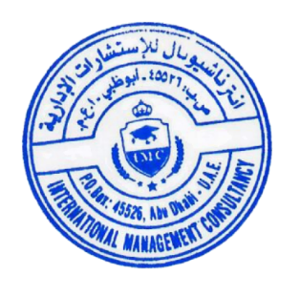
Name of the Trainer  External Trainer |  | For International Management Consultancy

